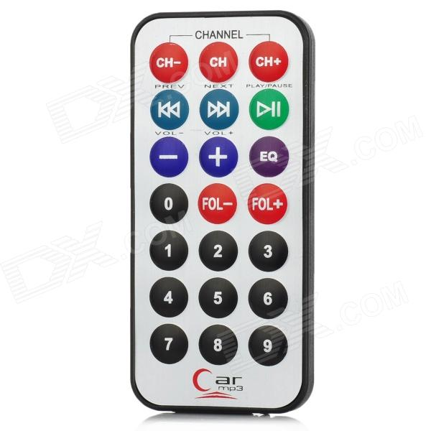**ARDUINO CAR REMOTE HEX VALUES**

|  |  |  |
| --- | --- | --- |
| S/N | Key | HEX Value |
|  | CH- | FFA25D |
|  | CH | FF629D |
|  | CH+ | FFE21D |
|  | I<< | FF22DD |
|  | >>I | FF02FD |
|  | >II | FFC23D |
|  | - | FFE01F |
|  | + | FFA857 |
|  | EQ | FF906F |
|  | 0 | FF6897 |
|  | 100+ | FF9867 |
|  | 200+ | FFB04F |
|  | 1 | FF30CF |
|  | 2 | FF18E7 |
|  | 3 | FF7A85 |
|  | 4 | FF10EF |
|  | 5 | FF38C7 |
|  | 6 | FF5AA5 |
|  | 7 | FF42BD |
|  | 8 | FF4AB5 |
|  | 9 | FF52AD |